Parkside Medical Centre
Newsletter

Thank you to our patients for working with us during this difficult time, what a year it has been for all of us. Our team have done an amazing job of being reactive to a lot of changes within a very short space of time, including new technology and working to ever-changing guidelines. The practice continues to offer the same amount of appointments, albeit in very different ways. Our nursing team turned to offering Home Visits for our Shielding patients, our GP’s and ANPs turned to video consultations and the introduction of our new SMS systems has allowed us communicate with you in a much easier and timely way. We couldn’t have done any of this without the help, support and most importantly the patience of our patients, we are all facing a challenging time and it’s important for us all to remember we are in this together. It is not the fault of the receptionist that we cannot book advanced appointments or book face to face without being triaged first, our team our doing a fantastic job and I ask that we continue to support them through this difficult time. The support from the community has been overwhelming and we thank everyone that dropped in the colourful pictures we were able to display on our doors.
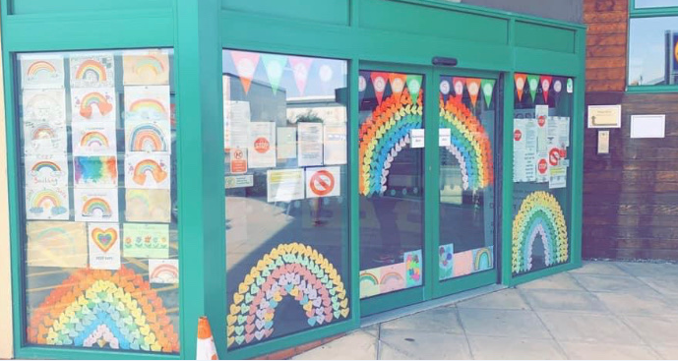
“Thank you to our patients for your continued support”
Dr Kiss and Dr Lawal

Exciting News
We’ve been expanding our clinical team, we have welcomed Dr Vine to the practice and Dr Elmo-Paul will be joining us permanently at the end of October. We also have a new service starting at the beginning of October, the First Contact Physiotherapy service offer’s expertise in Musculoskeletal conditions, patient are able to self-refer into the service rather than booking in with the GP first.

Access to appointments
Due to Covid 19 we have had to change the way we work. To ensure the safety of both clinical staff and patients, all patients are triaged over the telephone in the first instance. We are still offering Face to Face appointments if appropriate, these will be booked by the clinician. We are still offering the same amount of appointments that we were before the Covid 19 pandemic.

Telephone System
To ensure the safety of all patients and staff all patients have to be triaged for COVID-19 symptoms, this is to ensure patient’s with symptoms can be seen and treated safely in our designated Red area. Because of how we need to book we have had to temporarily turn off Online Booking and Patient Partner booking, this means that calls to the practice have increased exponentially. To help with demand we have increased our phone line capacity and have recruited 2 additional receptionists. We would like to thank our patients for your understanding during this very busy time; our reception team are busier than they had ever been before.

Myth Busters

Q: Has Parkside Medical Centre been closed during the Covid 19 Pandemic?
A: No, we temporarily set up a reception desk at our front door to control/manage access to the practice. All patients were/are consulted over the telephone in the first instance and were/are invited in for a face to face appointment if required. The reception desks have now been reinstated and patients are asked to come to the desk to limit the number of patients in reception at any one time.

Q. Have we stopped taking prescription requests by paper?
A. Where possible we are limiting footfall into the practice to reduce risk to staff and patients, because we receive a large number of prescription requests every day we ask that you use our script line or order your prescriptions online, however, if these are not accessible for you we will still accept your paper request. We do ask that if you are able to use the alternative methods that you do so to help us reduce footfall.

Q: Have we stopped providing standard services?
A: In most instances no, we have continued to provide most services but remotely where possible. All patients are consulted before attending the surgery. There are a few services which we have not yet reintroduced e.g. Ear Syringing and Spirometry, this is due to the nature of the procedure being a higher risk of generating Aerosol particles, these procedures will be introduced once professional guidance changes.

Q: Why do the staff ask me to wear a face mask when attending the surgery?
A: Wearing of a face mask offers protection to the patient but also offers protection to our staff. So far we have managed to keep Covid 19 away from our surgery and would really appreciate your co-operation to ensure that this continues. Also a face covering could be a scarf, cloth mask, surgical mask. There are many options available publicly.

Q: Will the Flu vaccination plan be different this year?
A: Yes, a little. The Normal groups eligible for Flu vaccinations are already being booked into the clinics being held at the Practice. We have had to look at the way we deliver the vaccinations to enable us to maintain social distancing. Previously we delivered the Flu vaccinations during a walk in clinic. This year we will be operating a Booked only clinic to manage overcrowding.

Q. I am in the new flu group, can I book an appointment
The practice was made aware of the additional groups at the same time as the general public. The practice orders its flu vaccines a year in advance for the cohort of patients that we routinely vaccinate every year, we are awaiting further guidance on how we will deliver the vaccine to the newly eligible patients but it is expected that this will not be undertaken until later in the year once our at risk patients have been vaccinated.

The following statement has been issued by NHS England:
Please note that people in the 50 to 64 year old age group will not be vaccinated until November and December, providing there is sufficient vaccine, and no appointments will be offered for this age group until then. This is to ensure that those who are most at risk are vaccinated first. If you are 50 to 64 and you are in one of the other groups which is eligible for the flu vaccination, for example you have a health condition which puts you at risk from flu, you will be invited earlier.

Please let us know how we are doing.
All patient feedback , both positive and negative is addressed in the same manner and reviewed by our Management team at the practice. We welcome your opinions and would encourage you to share them with us so that we are able to ensure we are delivering the best patient care possible.

