Parkside Medical Centre
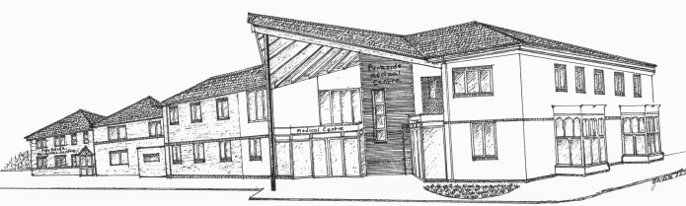
Statement of Purpose

The name and address of the registered provider is:

Parkside Medical Centre
Tawney St
Boston
Lincolnshire
PE21 6PF

Telephone: (01205) 365881
www.parkside-medicalcentre.co.uk

The practice is registered as a Partnership and there are 2 partners within the practice:

Dr Anton Kiss (Senior Partner)
Dr Jelili Lawal

The surgery is a purpose build premises attached to a Co-op owned Pharmacy, there is on site parking available to Staff and Patients and the practice is located directly opposite a Public carpark.

Parkside Medical Centre is also a training practice with registrars

Under the Health and Social Care Act 2008 (The Care Quality Commission (registration) Regulations 2009 Part 4), the registering body (Parkside Medical Practice) is required to provide to the Care Quality Commission a Statement of Purpose.

Our Aims and Objectives

To provide a high standard of medical care which is available to the whole population and to create a partnership between patient and healthcare professionals

Be committed to our patients needs

Act with Integrity and Confidentiality
- Be courteous, approachable and friendly
- To be open and honest – act within the ‘professional duty of candour’
- To recruit, retain and develop a highly motivated and appropriately skilled team who are committed to providing excellent patient care
- To ensure effective and robust information governance systems are in place
- Treat all patients with dignity, respect and honesty
- Ensure safe and effective services and environment
- Offer relevant health promotion advice and referral as appropriate, reflecting patient choice wherever practicable
- Thorough monitoring and quality improvement/auditing continue to improve our healthcare services.

Regulated Activities under CQC
- Treatment of disease, disorder or injury
- Surgical procedures – Minor Surgery
- Diagnostic and screening procedures
- Maternity services
- Family planning and contraceptive services

The registered activities have been agreed by the partners at Parkside Medical Centre in accordance with CQC guidance. The registered activities under CQC are:

- Routine Medical checks and general medical services
- NHS relevant prescriptions and medications or a private prescription can be issued
- Vaccinations and immunisations – the practice supports the childhood immunisation programme. All routine childhood vaccinations are performed at the surgery by one of our practice nurses. We also offer our ‘at risk’ patients the seasonal influenza vaccination from September to March each year.
- NHS Foreign travel immunisations – provided by our practice nurses
- Medicals – the GP’s carry out medical reports and examinations
- Chronic Disease management – this encompasses a wide range of conditions which require long term management and care. Our priority is to ensure this care is on-goi ng and appropriate and we endeavour to review patients medication on an ongoing annual basis.
- Family planning and contraceptive services – this is provided by the doctors and nurses
- Phlebotomy – We offer an in house service carried out by our Health Care Support Worker
- Maternity Services – The practice has a midwife that holds weekly clinics in the practice
- Minor Surgery – appointments are available for some dermatology related conditions
- Cervical Screening – this service is provided by our trained practice nurses

Our practice strives towards bettering the partnership between patients and healthcare professionals, and we do this based on the following:

Mutual Respect
We endeavour to treat all of our patients with dignity, respect and honesty. Everyone at the surgery is committed to providing excellent patient care.

Continuity of Care
Building and maintaining a strong relationship between health professionals and our patients is essential to the way we work. This is especially the case when dealing with patients who have long term conditions. In these circumstances, we encourage patients to see, wherever possible, the same health professional and we will endeavour to do this through our appointment system. However, if a patient finds that the doctor or nurse they usually see is not available, then we would encourage the patient to see any of the doctors or nurses and the practice. Continuity for all patients to see any of the doctors or nurses at the practice. Continuity for all patients is promoted through regular internal meetings and communications.

Learning and Training
The practice is a training practice and we are committed to the training of doctors and nurses, who are closely supervised. We recognise the vital role students have in keeping the practice fresh and reflective. All staff within the practice has an annual appraisal where their training needs are identified. We also recognise the benefit of supported learning for patients to enhance the ability to self-manage and deal with long term conditions. The practice trainers are: Dr Lawal, Dr Teckchandani and Dr Kuttappan.

Patient Participation Group
Parkside Medical Centre has an active patient group that meets every two months. We listen to the views of our patients and utilise the group to discuss any changes that we wish to make.

